**Year 7 Biological Sciences 2022**

***Midterm Test - Classification***

**Section 1: Multiple Choice Questions (28 marks)**

Read all answers and choose the **BEST** one. **(1 mark each)**

1. Which of the following is **not** an insect?

a) beetle

b) ant

c) redback spider

d) mosquito

1. A **vertebrate** is:

a) An animal with no backbone

b) An animal with a backbone

c) An animal with an external skeleton

d) An animal that eats other animals

1. Identify the **Kingdom** that matches the description below:

*Multicellular organisms with a distinct nucleus but without cell walls. Lack chlorophyll.*

1. Monera
2. Fungi
3. Plant
4. Animal
5. Identify the **Kingdom** that matches the description below:

*Microscopic single-celled organisms* ***withou****t a distinct nucleus.*

1. Monera
2. Fungi
3. Protista
4. Animal

1. Identify the **Kingdom** that matches the description below:

*Multicellular organisms with cell walls but without chlorophyll.*

1. Monera
2. Fungi
3. Protista
4. Animal
5. An animal with an **exoskeleton** has:

a) An external skeleton

b) An internal skeleton

c) Eight legs

d) A shell on its back

1. Identify the five animals that are **invertebrates**:

a) Worm, jellyfish, spider, elephant, eagle

b) Eagle, tiger, shark, crocodile, frog

c) Crab, scorpion, snail, worm, jellyfish

d) Jellyfish, snake, worm, eel, salamander

1. Which of the following species names is written correctly?

a) *Bos Taurus*

b) *Bos taurus*

c) Bos taurus

d) *bos Taurus*

1. Which of the following is true for Centipedes?

a) They belong in the class of Insects

b) They are a phylum in the Animal Kingdom

c) They are part of the same class as Millipedes

d) They are a class of Arthropods

1. What is Carolus Linnaeus known for?

a) Dichotomous Keys

b) The Linnaean Taxonomy

c) Binomial Nomenclature

d) Both b and c

1. Both these animals belong to the Arthropod phylum.

Propose the characteristic that is not typical of all members of this phylum.

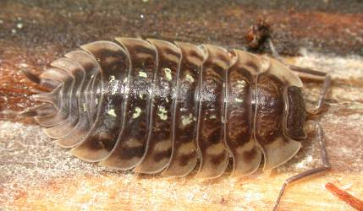

a) The presence of jointed legs

b) Having segmented bodies

c) Having an exoskeleton

d) Having a pair of long antennae

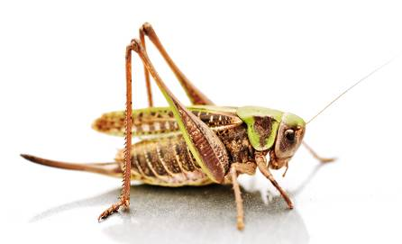

1. Select the best description of the term ‘binomial nomenclature’.

a) A system or scientific naming that was used in the past but is no longer used.

b) Using only two names to identify any living thing.

c) A system of naming that does not change.

d) A shorthand version of the name of an organism.

1. Select the plants from this group that are most closely related.

*Hakea sericea*

*Grevillea sericea*

*Hakea pachyphylla*

*Acacia pachyphylla*

a) *Hakea sericea, Grevillea sericea*

b)  *Acacia pachyphylla, Hakea pachyp*hylla

c) *Hakea sericea, Hakea pachyphylla*

d) *Grevillea sericea, Acacia pachyphylla*

1. Students created this key for their group.

|  |  |  |
| --- | --- | --- |
| 1a | male | go to 2 |
| b | female | go to 5 |
| 2a | straight hair | go to 3 |
| b | curly hair | go to 4 |
| 3a | can roll tongue | Mark |
| b | cannot roll tongue | Yasu |
| 4a | brown eyes | Hans |
| b | grey eyes | Jack |
| 5a | straight hair | Jane |
| b | curly hair | Mai |

Identify the description of Jack.

a) Straight-haired male with brown eyes that cannot role his tongue.

b) Curly-haired male with grey eyes.

c) Male that can roll his tongue and has grey eyes and curly hair.

d) Male with straight hair and brown eyes.

1. In the scientific name of an organism, the first part is called a (an)
2. Order
3. Genus
4. Family
5. Class
6. Which of the following taxonomic categories refers only to plants?
7. phylum
8. division
9. class
10. kingdom
11. Biologists classify organisms based on
12. their appearance
13. their structure.
14. their ability to interbreed.
15. All of the above
16. Animalia, Protista, Monera, Fungi, and Plantae are the
17. scientific names of different organisms.
18. names of kingdoms.
19. levels of classification.
20. scientists who organized taxonomy.
21. Bears, lions, and house cats give birth to live young, and lions and house cats have retractable claws. Which of the three types of animals are most closely related?
22. lions and house cats
23. lions and bears
24. house cats and bears
25. None of the animals are related.
26. What do amphibians, bony fish and birds have in common?
27. They have scales
28. They are vertebrates
29. They use energy to maintain their body temperature
30. They lay eggs with soft shells
31. What do insects and molluscs have in common?
32. They are invertebrates
33. They have six legs
34. They have soft bodies
35. They use energy to maintain their body temperature
36. What do reptiles, birds and mammals have in common?
37. They lay eggs with hard shells
38. They reproduce by external fertilisation
39. They use energy to maintain their body temperature
40. They have lungs
41. What is an arthropod with three pairs of legs likely to be?
42. An insect
43. A crustacean
44. A myriapod
45. A centipede
46. Organisms which use the food they eat to keep their body warm are called …
47. autotrophs
48. endotherms
49. heterotrophs
50. ectotherms
51. Members of a species ...
    1. usually have different scientific binomial names
    2. are all identical to one another
    3. may belong to different genera
    4. are able to mate to produce fertile offspring
52. In a five-kingdom system of classification, bacteria are members of which kingdom?
    1. monera
    2. fungi
    3. protests
    4. plants
53. Which of the following groups of plants reproduce by seeds but do not have a fruit or flowers?
    1. mosses
    2. ferns
    3. liverworts
    4. conifers
54. A key which offers only two choices at any point is called a _____ key.
55. branching
56. circular
57. dichotomous
58. tabular

**- End of Multiple Choice Questions -**

Turn to Short Answer section

|  |  |
| --- | --- |
| Mount Lawley Senior High School - Wikipedia | **Mount Lawley Senior High School** |
| **Year 7 2022 – Biological Science – Mid Unit Test: Classification** |
| Name: ___________________________________________________________  Class: _____________________________ Date:_____________________ |

***Section A: Multiple Choice – Please SHADE he best suited answer* 28 marks**

1. A B C D
2. A B C D
3. A B C D
4. A B C D
5. A B C D
6. A B C D
7. A B C D
8. A B C D
9. A B C D
10. A B C D
11. A B C D
12. A B C D
13. A B C D
14. A B C D
15. A B C D
16. A B C D
17. A B C D
18. A B C D
19. A B C D
20. A B C D
21. A B C D
22. A B C D
23. A B C D
24. A B C D
25. A B C D
26. A B C D
27. A B C D
28. A B C D

**Multiple Choice: _________ /28**

**Short Answer: ________ / 34**

**TOTAL: ________ / 62**

**Section 2: Short Answer 34 marks**

1. What is a group of organisms that are closely related and can mate to produce fertile offspring called? ________________________ (1 mark)

**species**

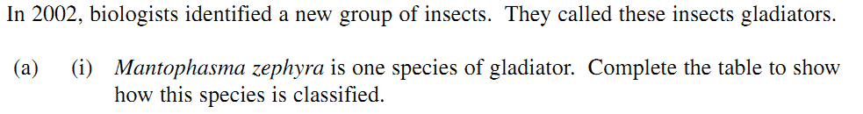2.

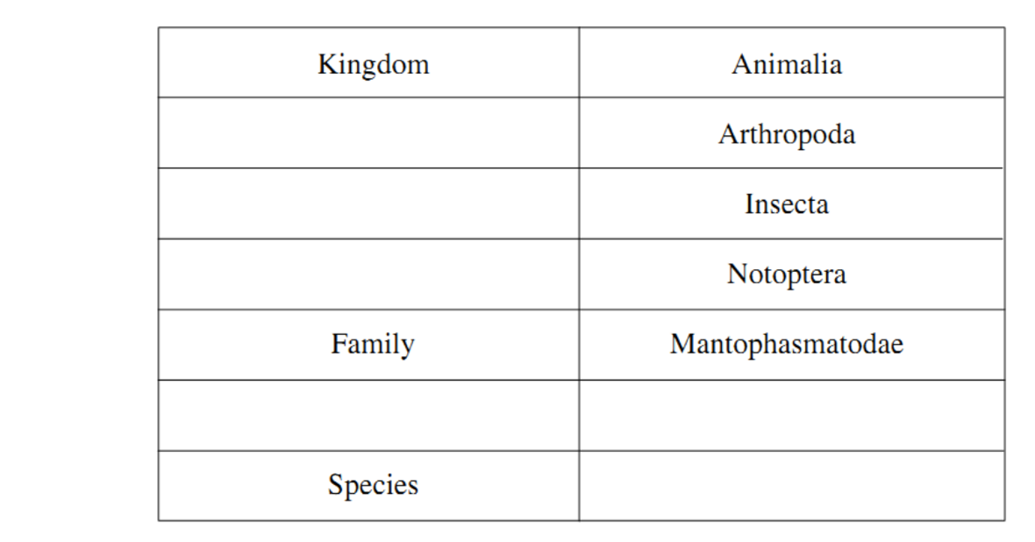

(3 marks)

**Phylum**

**Half mark each**

**genus & species must be UNDERLINED**

**Genus must be capitalised**

**Species lowercase**

**Class**

**Order**

***Mantophasma***

**Genus**

***zephyra***

3. **a) Name** the 7 main processes that all living organisms perform (4 marks)

**Growth**

**Movement**

1. ______________________ 2. _____________________

**Reproduce**

**Deduct ½ mark for incorrect answer**

**Respiration**

3. ______________________ 4. _____________________

**Excrete waste**

**Sensitivity**

5. ______________________ 6. _____________________

**Nutrition required**

7. ______________________

**b) Describe** any **1** of the processes above. (1 mark)

**suitable explanation**

Description for ____________________: ______________________________________________

________________________________________________________________________________

.

4. Write the word equation (OR **correct** formula equation) for: (2 marks)

**sunlight**

a.) photosynthesis

carbon dioxide + water 🡪 glucose + oxygen

**chlorophyll**

________________________________________________________________________________

b.) cellular respiration

glucose + oxygen 🡪 carbon dioxide + water + energy for the cell

________________________________________________________________________________

**Half a mark if missing any part**

5. Using the dichotomous key provided below, describe *all* the characteristics of: (3 marks)

**Antennae front of head + very long rear legs + small or no wings**

a) a mosquito ________________________________________________________

_________________________________________________________________________

**Antennae rear + very long rear legs + small no wings**

b) a grasshopper _____________________________________________________

_________________________________________________________________________

**Small eyes + not horned head +short rear legs**

c) a termite soldier ___________________________________________________ _____________________________________________________________________

**Full mark for all three characteristics or half a mark for one or two**

6 a) How are fungi and plants similar? (2 marks)

______________________________________________________________________________________________________________________________________________________________ ______________________________________________________________________________________________________________________________________________________________

**One mark per similarity – eg both have a cell wall, both have a nucleus**

**Multicellular = ½ mark as fungi can be uni cellular as well.**

b) Why are they placed in different Kingdoms? (2 marks)

**One mark per reason**

**– plants perform photosynthesis/have chlorophyll but fungi can not/don’t have chlorophyll**

* **Fungi are heterotrophs – plants are autotrophs**

**MUST clearly state the difference between BOTH not just a feature of one kingdom**

______________________________________________________________________________________________________________________________________________________________ ______________________________________________________________________________________________________________________________________________________________

7.

Name two *characteristics* (features or structures) that these four animals share. (2 marks)

**In the animal kingdom so are multicellular, no cell wall, have nucleus**

a)_____________________________________________________________________________b)_____________________________________________________________________________

**All chordates – have backbone / are vertebrates**

c) Which level of classification includes the most specific characteristics and only one type of organism?

**species**

____________________________________________________________________ (1 mark)

**order**

d) Would you find more species in a family or in an order? _____________________ (1 mark)

e) Why? (1 mark)   
_____________________________________________________________________________ _____________________________________________________________________________

**Order is a larger group of families with similar features**

f) What is the scientific name (correctly written) of the elephant? (1 mark)

***Loxadonta africana***

***Must have capital/lowercase letter and be underlined or NO mark***

______________________________________________________

g) Which two organisms are the most closely related? (1 mark)

**Elephant & human – must have both no half mark**

______________________________________________________________________________

h) If two animals belong to the same order, to what other groups must they also belong? (2 marks)

**phylum & class – 1 mark each**

______________________________________________________________________________

i) What can you conclude about an organism whose scientific name is *Crotalus transversus*?  
 (1 mark)

**It would be a type of snake / viper**

________________________________________________________________________

**READ CAREFULLY:**

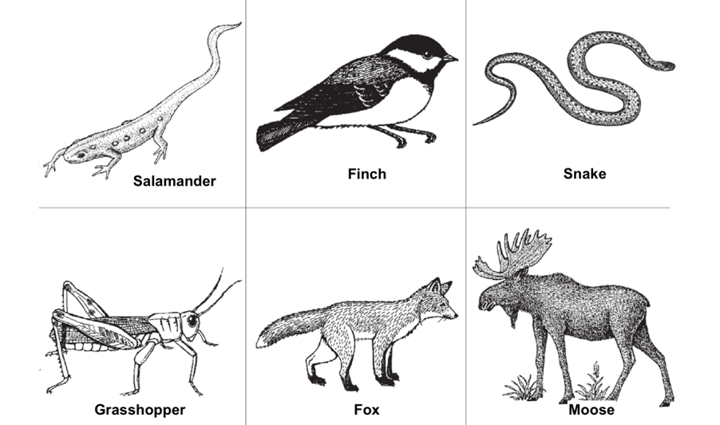8. Make a branching **OR** tabular dichotomous key to identify the following animals shown below:

(6 marks)

*(NOTE: Turn to next page for a table if you choose tabular key)*

**One mark for each correctly classified animal in either branching or tabular key**

½ mark for weak keys: long/short, behaviours ‘fly/not fly’. No mark for classification: chordate / Arthropod

Horns accepted instead of Antlers

***Branching Dichotomous Key***

***Tabular Dichotomous Key***

|  |  |  |
| --- | --- | --- |
|  |  |  |
|  |  |  |
|  |  |  |
|  |  |  |
|  |  |  |

**- END OF TEST -**

***EXTENSION SECTION***

*The marks below do NOT go towards your reports.*

Use the description of an organism to determine which Phylum it would belong to. *(9 marks)*

|  |  |
| --- | --- |
| **Description** | **Phylum** |
| Invertebrate with bilateral symmetry. Round body without segments. | Nematode |
| Mostly marine living. Have pores that filter out food from the water. | Poriferan |
| Organism with stinging cells and only one opening. It has radial symmetry. | Cnidarian |
| Has bilateral symmetry and a spinal cord. Has an endoskeleton. | Chordate |
| Flat body. Invertebrate with bilateral symmetry. Generally, very colourful. | Platyhelminthes |
| Has an exoskeleton with jointed limbs and a segmented body. | Arthropod |
| An organism that has spiky skin and radial symmetry. | Echinoderm |
| Invertebrate with a muscular foot and well-developed internal organs. | Mollusc |
| Has rings along its segmented body and a cylindrical body shape. | Annelid |